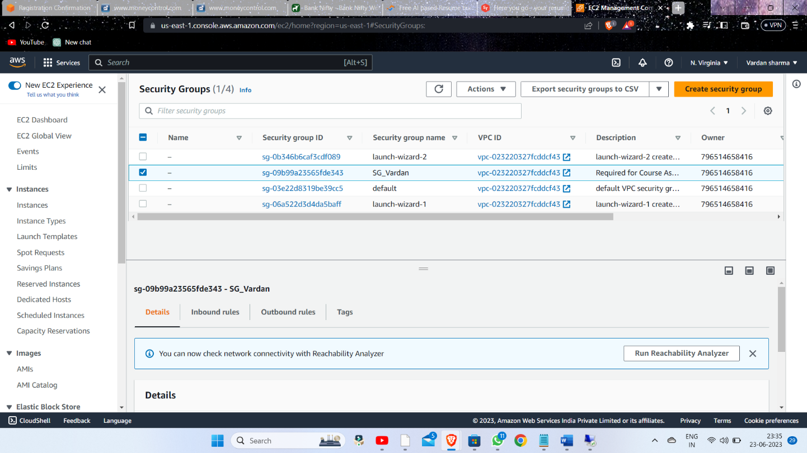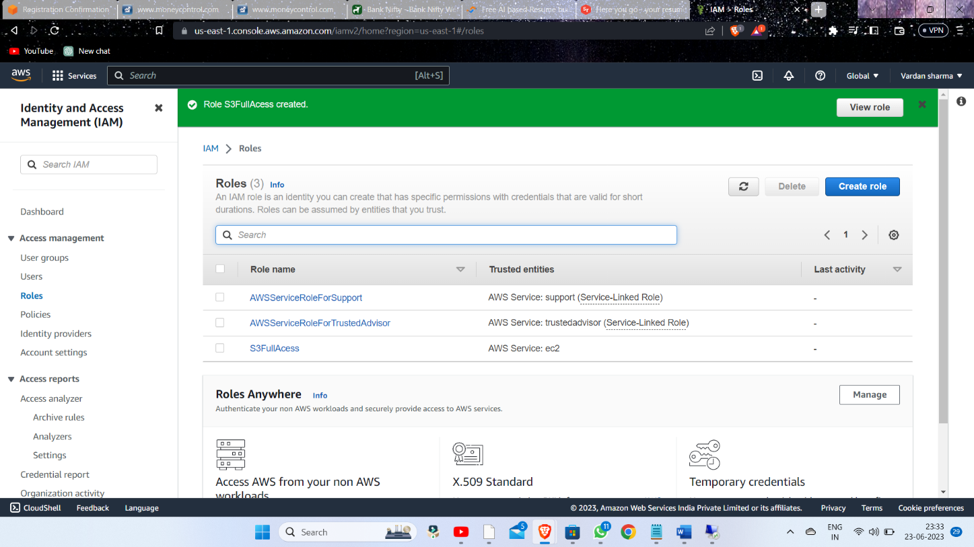

2.) Creating the Security Group Name "SG_Vardan"

1.) Creating I AM Role Name"S3FullAccess"

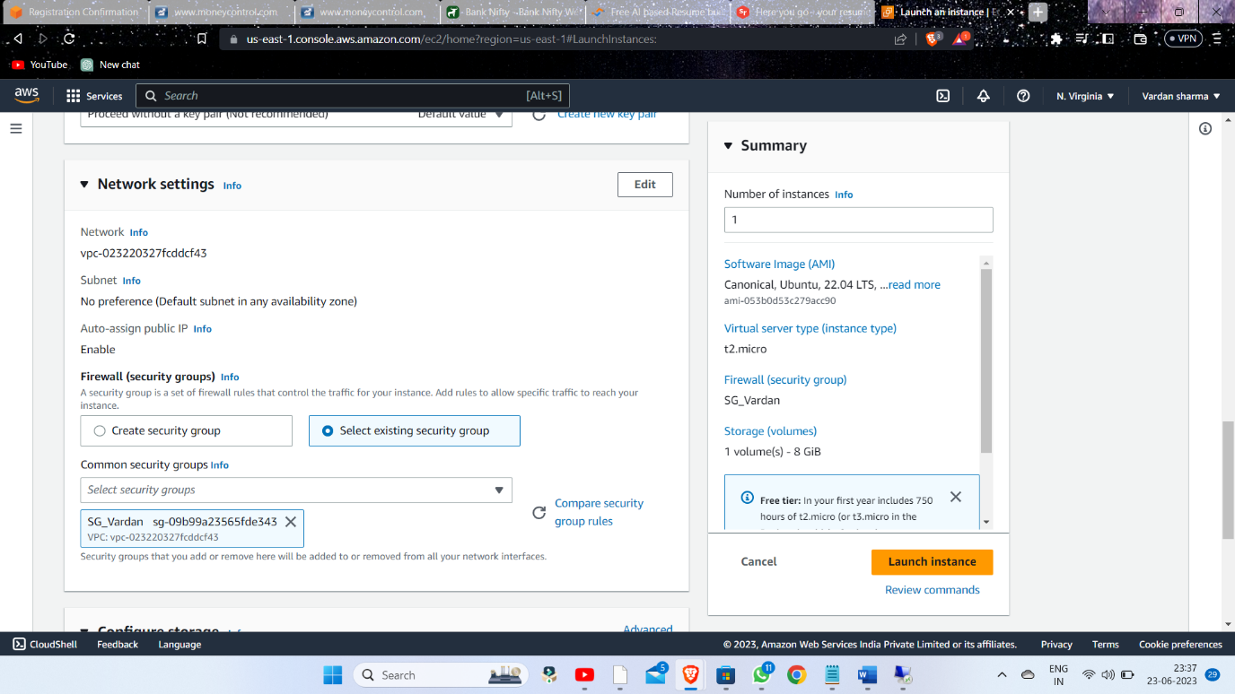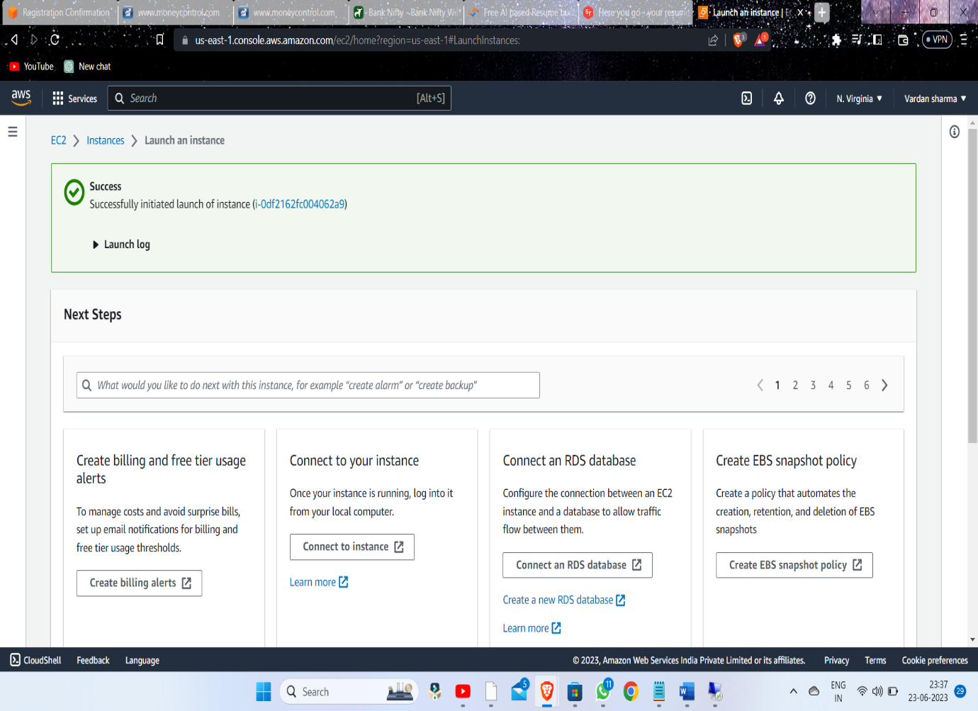

4.) Successfully Created the the instance

3.) Creating a instance selecting existing Security Group

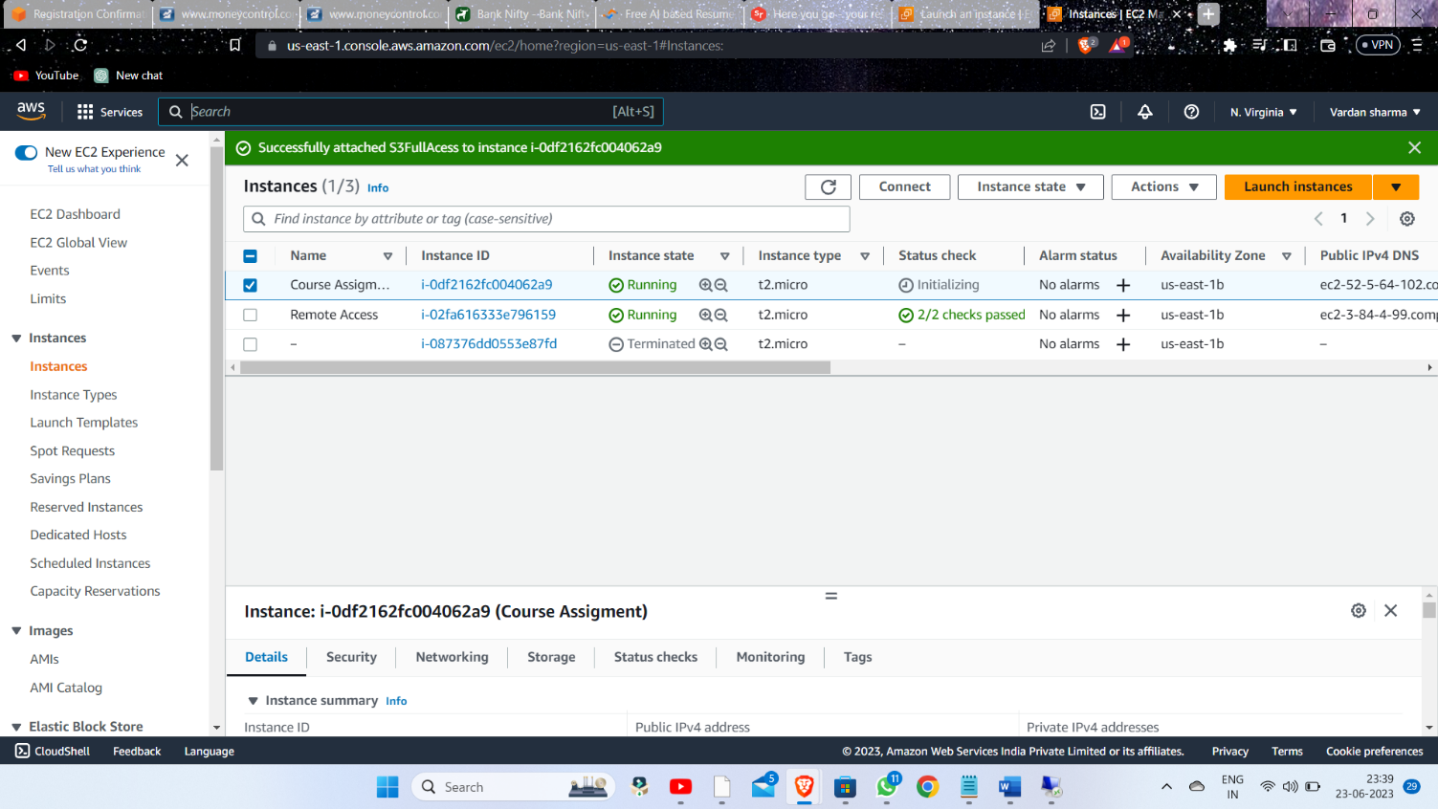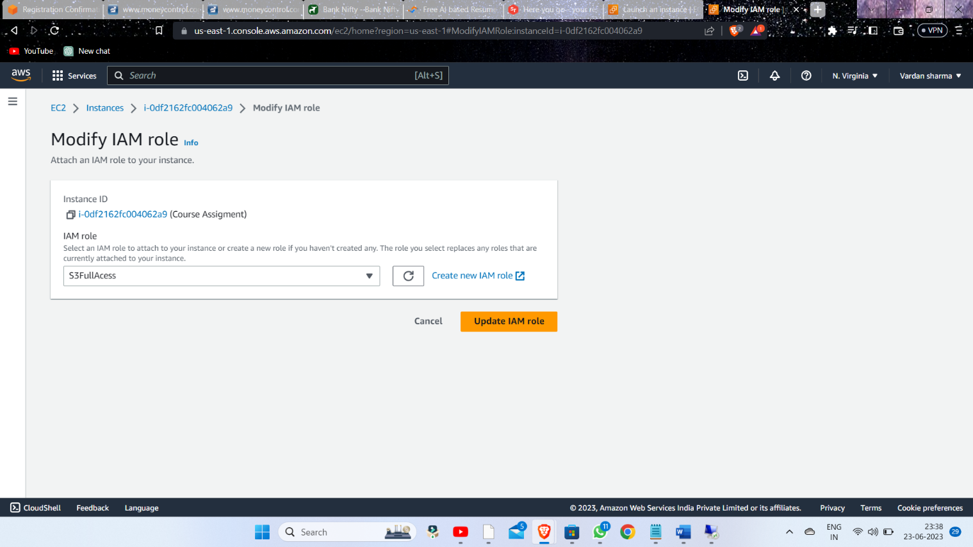

5.) Modify the instance with our created I AM role

6.) Successfully attached the S3FullAccess to instance

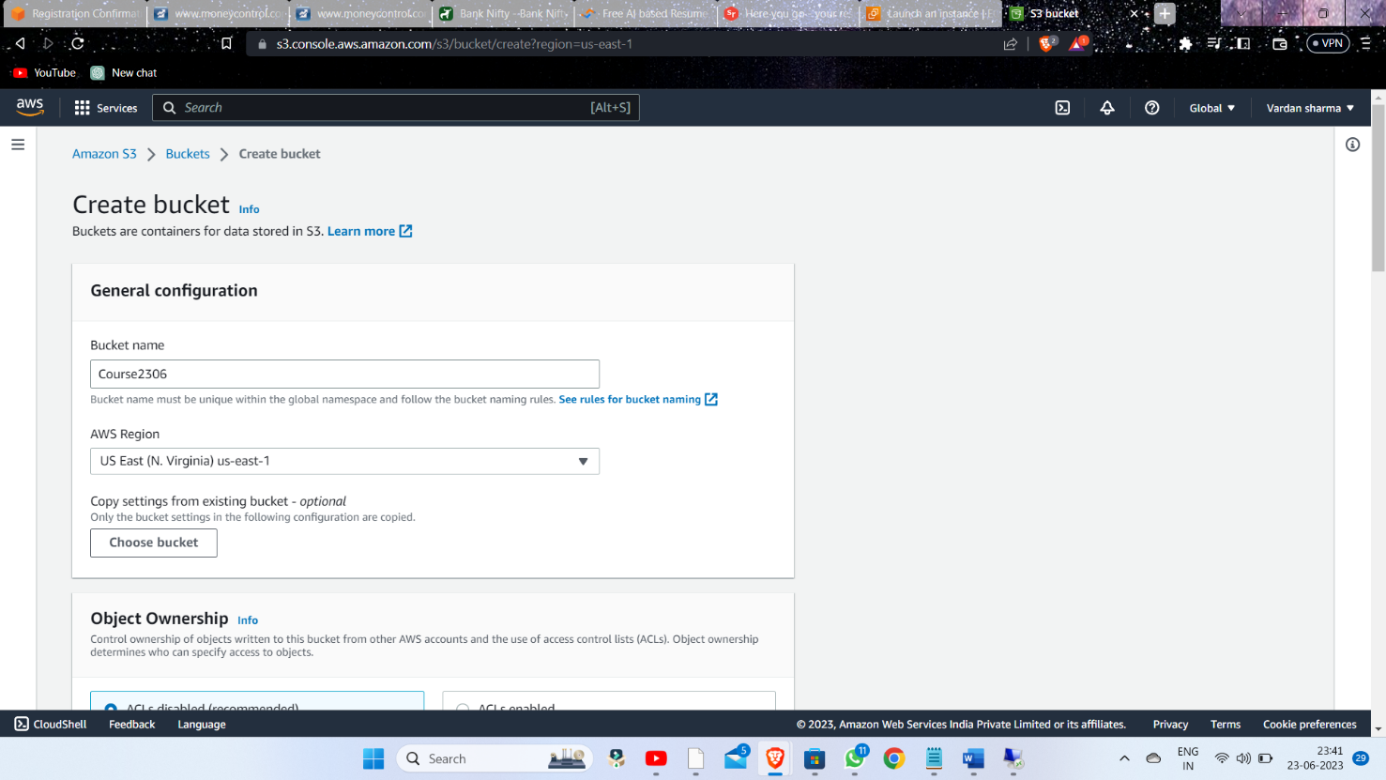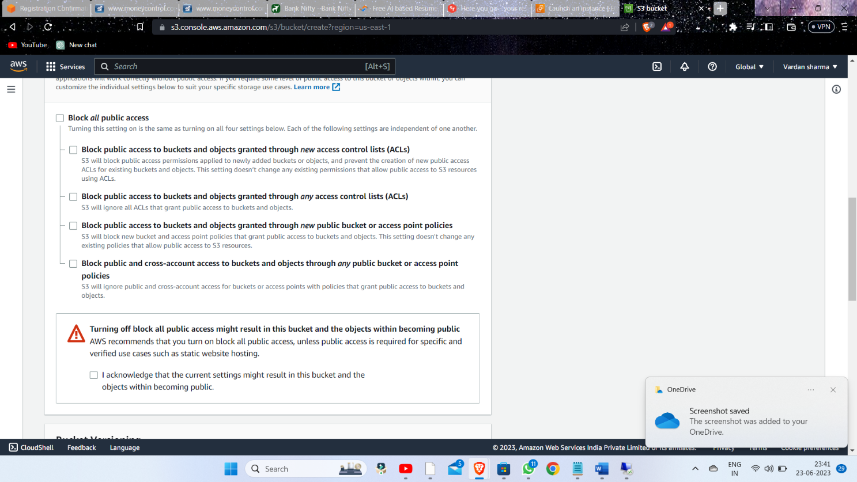7.) Creating the S3 bucket Name Course2306

8.) Allowing the public access

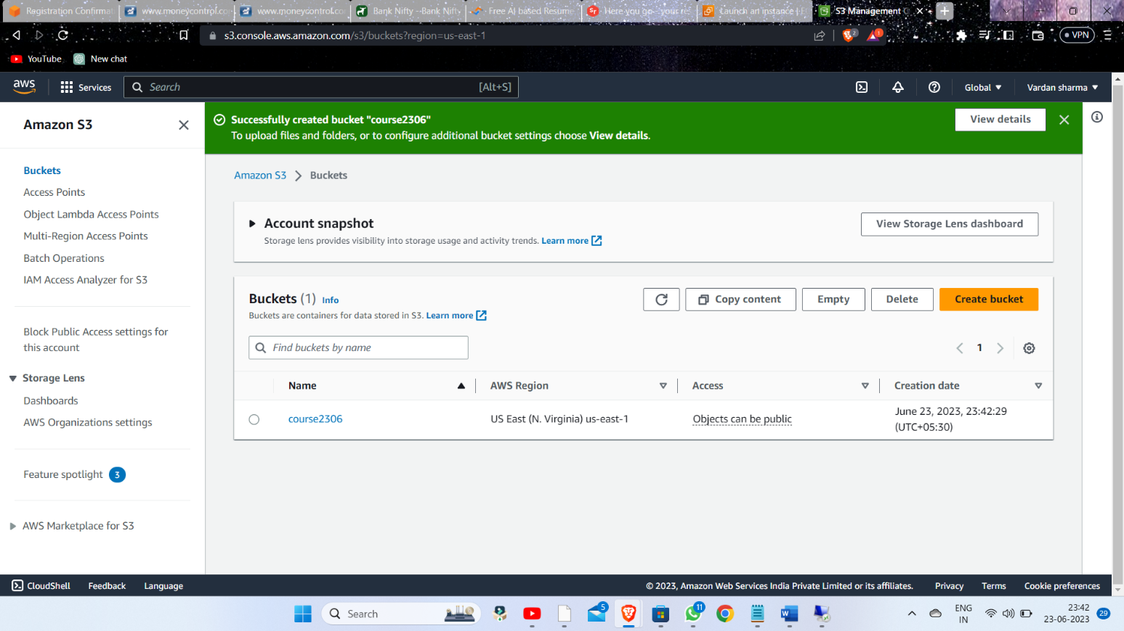9.) Bucket successfully Created